# 4 Hello Craig

Moist curry rice

Here is an image of three dogs

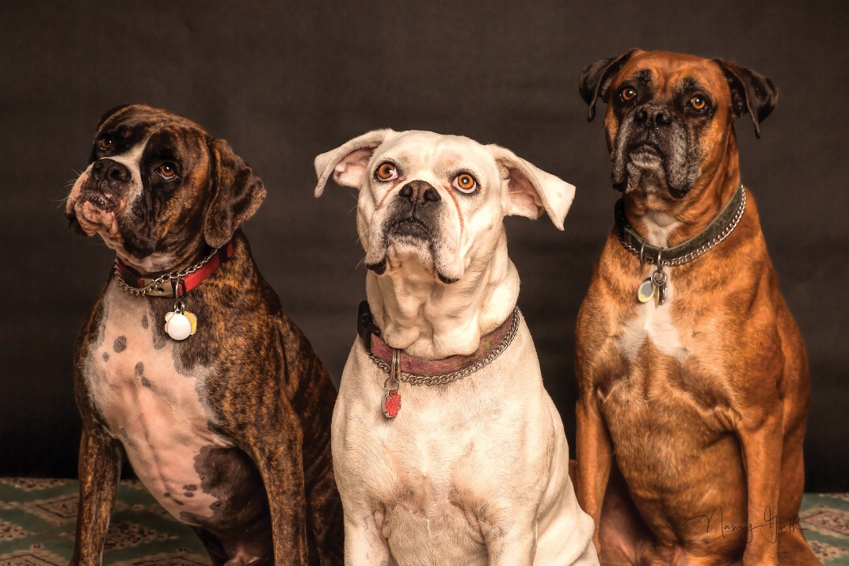

And here is an image of a baby duck

